Biblical Mindfulness

God on our mind & thoughts
Romans 12:2; Mark 12:30, 1 Peter 4:7 (NLV) Ephesians 4:22-24, Jeremiah 17:5-8,
Philippians 4:6-7, 2 Corinthians 2:16, Habakkuk 3:17-18

Prime Directives/Role our Unconscious Mind

- Stores memories
- Organizes all memories
- Represses memories with unresolved negative emotion
- Presents repressed memories for resolution – to make rational and to release emotion
- Runs the body
- Preserves the body
- Is the domain of the emotions
- Is a highly moral being
- Enjoys serving, needs clear orders to follow
- Controls and maintains all perceptions
- Generates, stores, distributes, and transmits energy
- Maintains instincts and generates habits
- Needs repetition until a habit is installed
- Functions best as a whole integrated unit
- Is symbolic – uses and responds to symbols
- Takes everything personally – the basis of Perception is Projection
- Works on the principle of least effort
- Does not process negatives

Mindfulness:
- The quality or state of being conscious or aware of something
- A mental state achieved by focusing one’s awareness on the present moment, while calmly acknowledging and accepting one’s feelings, thoughts, and bodily sensations – all five senses
- Being aware of or bringing attention to this moment in time, deliberately and without judging the experience
- Awareness with detachment – not clinging, holding emotions lightly
- Moving from an associated/hooked to a dissociated/unhooked state
- Choosing values over suffering
- Psychological flexibility, openness & curiosity - “Those who can adapt win.”
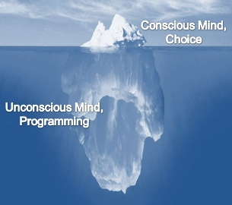
- Not allowing the difficulties of life & related emotions to dictate our next decisions and feelings

Mindfulness Exercise:
- I feel/think…..
- I notice I feel/think….
- Values to focus on…
- Scriptures to focus on….

Declarations:

- I am blessed.
- I am prosperous.
- I am talented.
- I am creative.
- I am forgiven.
- I am redeemed.
- I am free.
- I am valuable.
- I am anointed.
- I am equipped.
- I am beautiful.
- I am attractive.
- I am amazing.
- I am fearfully and wonderfully made.
- I am a child of the Most High God.
- I have seeds of greatness.
- I will become all He's created me to be.
- I am victorious in Jesus name!

www.cresendajones.com

