Self-management Skills Personal Inventory
How frequently to you employ the following self-management skills?

ALWAYS – 4 | OFTEN - 3 | SOMETIMES - 2 | RARELY - 1 | NEVER - 0

SKILL | SCORE
1. Breathe Right
2. Create an Emotion vs. Reason List
3. Make Your Goals Public
4. Count to Ten
5. Sleep On It
6. Talk To a Skilled Self-Manager
7. Smile and Laugh More
8. Set Aside Some Time in Your Day for Problem Solving
9. Take Control of Your Self-Talk
10. Visualize Yourself Succeeding
11. Clean Up Your Sleep Hygiene
12. Focus Your Attention on Your Freedoms Rather than Your Limitations
13. Stay Synchronized
14. Speak to Someone Who is Not Emotionally Invested in Your Problem
15. Learn a Valuable Lesson from Everyone You Encounter
16. Put a Mental Recharge into Your Schedule
17. Accept That Change is Just around the Corner
TOTAL SCORE out of 68
Bradberry, Travis; Jean Greaves. Emotional Intelligence 2.0 (p. 100). TalentSmart.

Inventory scoring scale

61 + | A strength to capitalize on
54 - 60 | A strength to build on
48 - 53 | With a little improvement, this could be a strength
41 - 47 | Something you should work on
40 and below | A concern you must address
Not a scientifically validated scoring scale
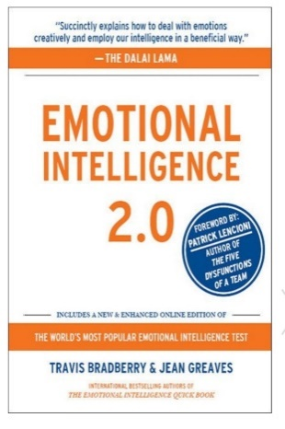
In today's fast-paced world of competitive workplaces and turbulent economic conditions, each of us is searching for effective tools that can help us to manage, adapt, and strike out ahead of the pack.
By now, emotional intelligence (EQ) needs little introduction—it’s no secret that EQ is critical to your success. But knowing what EQ is and knowing how to use it to improve your life are two very different things.
Emotional Intelligence 2.0 delivers a step-by-step program for increasing your EQ via four, core EQ skills that enable you to achieve your fullest potential:
1) Self-Awareness
2) Self-Management
3) Social Awareness
4) Relationship Management
Emotional Intelligence 2.0 is a book with a single purpose—increasing your EQ.
Includes and EQ appraisal and 66 skills for increasing your EQ.

https://www.talentsmarteq.com/emotional-intelligence-2-0/

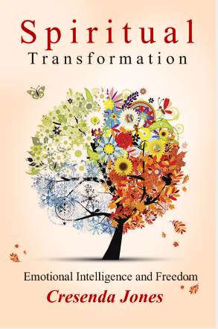
For spiritual growth, emotional intelligence is a blind spot or a missing link for many of the “fires” ministers have to attempt to put out. EQ is the missing link for many involved in the restoration-of-purity ministry. EQ is the missing link for disciples who just can’t seem to get unstuck in their lives. EQ, no matter how committed we are to spiritual disciplines, is imperative for many and their relationship with God, peak performance and growth.

Book topics include:
- Take the Emotional Intelligence 2.0 appraisal – assessment is imperative!
- Life without EQ
- What is EQ?
- Master Your Mind
- The Cost of Repressing Emotions
- God, Emotions and Emotional Intelligence
- The Bible on the Four Core EQ skills
- Build Your EQ skills - The Bible on Emotional Intelligence 2.0’s 66 Strategies
- Time Line Therapy® - Transforming our Neurology
- Three Requisites for Mind Changes and Soul Transformations
- Is There Anything Helpful Outside of God’s Word?
- Testimonies

https://www.ipibooks.com/collections/new-releases/products/spiritual-transformation

