Check Your Thoughts, Beliefs & Decisions

Read the following statements and note how often each statement applies to you on a level of 0 to 3. Mark your answers in the space provided.

0 = Never 1 = Sometimes 2 = Often 3 = Always

___ I am not knowledgeable enough; this is why I am reluctant to change anything in my life.
___ I don’t believe in myself.
___ I’ve never been given a chance.
___ I wish I had more self -confidence.
___ I have fear of rejection.
___ I pretend to be self-assured, but inside I am very timid.
___ I am afraid of a challenge. In fact, I hate it. It’s just too hard.
___ I feel resentful and critical when looking at successful people. Why not me?
___ I have done a lot of inner work and have applied the Law of Attraction, yet I have not succeeded.
___ I get anxious when I step outside of my comfort zone.
___ I made mistakes in my past, which led to deep hurt. Never again.
___ I feel guilty, even when I don’t do anything wrong.
___ I had a difficult childhood. I’ll never overcome that.
___ I blow up at my spouse/kids and it’s always their fault. They really make me angry.
___ I worry that I am not a good enough parent to my children.
___ I can’t discipline myself enough.
___You have to put up with things you don’t like. That’s life.
___ I’m afraid of heartbreak because I was betrayed in a previous relationship.
___ My family does not appreciate or understand me.
___ I am not important.
___I am always worried about what other people will say about me if I do or don’t do something.
___I’ve had lots of emotional pain in my life.
___ I should be happy and grateful for what I have. Why try for more?
___ I have too much on my plate.
___I had a lot of hardships in my life and I feel worn out. Total Points: ________

Florida Discipleship Conference!!
Join Us Saturday @ 4:30 p.m.
Room Antigua 1-4

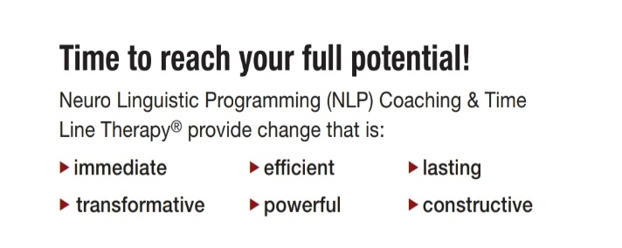
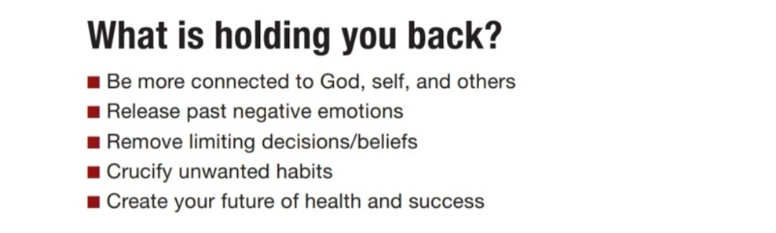

When have you felt angry?
___________________________________________________________________________________
___________________________________________________________________________________
When have you felt sadness/grief?
___________________________________________________________________________________
___________________________________________________________________________________
When have you felt fear/worry/anxiety?
___________________________________________________________________________________
___________________________________________________________________________________
When have you felt hurt?
___________________________________________________________________________________
___________________________________________________________________________________
When have you felt guilty?
___________________________________________________________________________________
___________________________________________________________________________________

